Guidance on How to Report an Incident using Safeguard

Guidance on how to report an incident

If you would like assistance with the registration process or completing an incident form, please contact Lisa Radoje 07702 975909 during normal working hours. If you experience any difficulties or error messages, email safeguard@eryccg.nhs.net

Definition of an incident
An incident is any event which affects a patient, member of staff, visitor or contractor, which could have (near miss) or actually caused harm, while he or she is on CCG premises. Additionally, any event which causes loss or damage to property or premises belonging to the CCG, or the property of any persons identified above.

Contingency
If the form is not available through the Vale of York CCG intranet site, please call Lisa Radoje on 07702975909. Please leave your contact details, so that you can be contacted if further information is required.

Location of form
The form is located at - http://srv-uly01/Safeguard/index.aspx?sid=%20

For ease, it is possible to save the Safeguard Welcome Page to your desktop or to add it to your favourites.

You will need to register the first time you use Safeguard, guidance below for the registration process. Once the registration process has been completed, you will receive a registration key for first time log in. You can then choose your user ID and password.

How to complete an incident form

On the left hand side of the screen are 6 blue boxes. Please click onto New VoY Incident to enter a new incident. Just above and to the right of this is ‘Manage Incidents’. This will contain all those incidents you have ‘saved for later’. You have approximately 1 hour to complete the form before you are timed out. If you are interrupted or taking longer than 1 hour to complete the form, please go to the bottom of the form (shortcut key – press <end> on keyboard) and ‘save for later’. Please note that while the incident is ‘saved for later’ your manager is not aware of the incident. Your manager will only receive notification when you press ‘submit’.

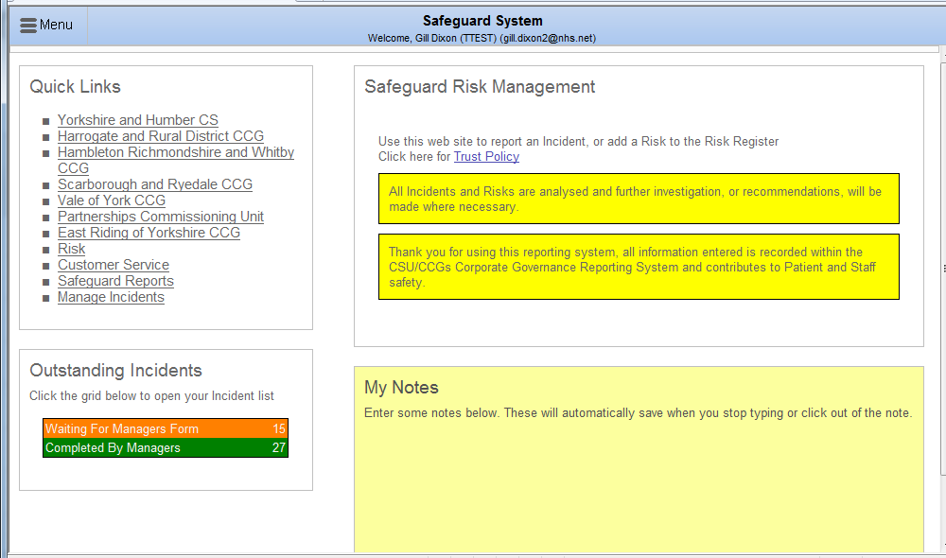
Click here

Entering an Incident
Use this form to report near misses and actual incidents. Please note yellow fields are mandatory

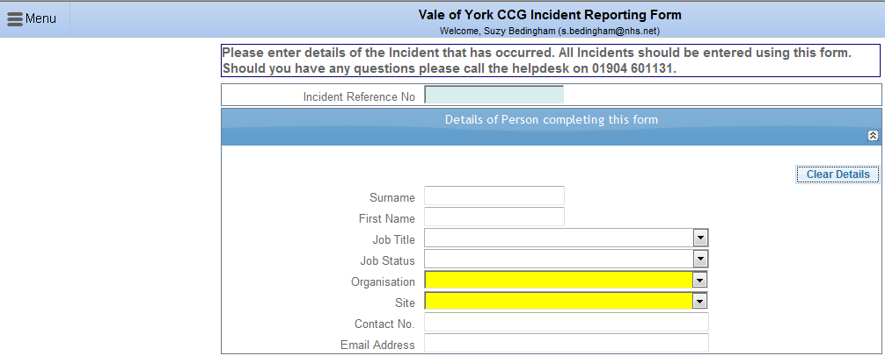

Incident Reference Number | This will be automatically generated when you submit the incident
Details of the person completing this  form | Once you have entered your login and password, completed your first incident and it has been merged into the live system, the next time you login, your name and details will be loaded onto the form automatically.  If this section is not completed (see above), please add your details as it is important to note who the incident is reported by

People Involved in the Incident

One of the following four options MUST be chosen:

- Patient
- Staff
- Visitor (Other non staff)
- Non Person – use this for infrastructure or building incidents, for example fire and vandalism where no individuals have been directly involved.

The details for up to three persons can be added to this section:

First Subject Details

Staff

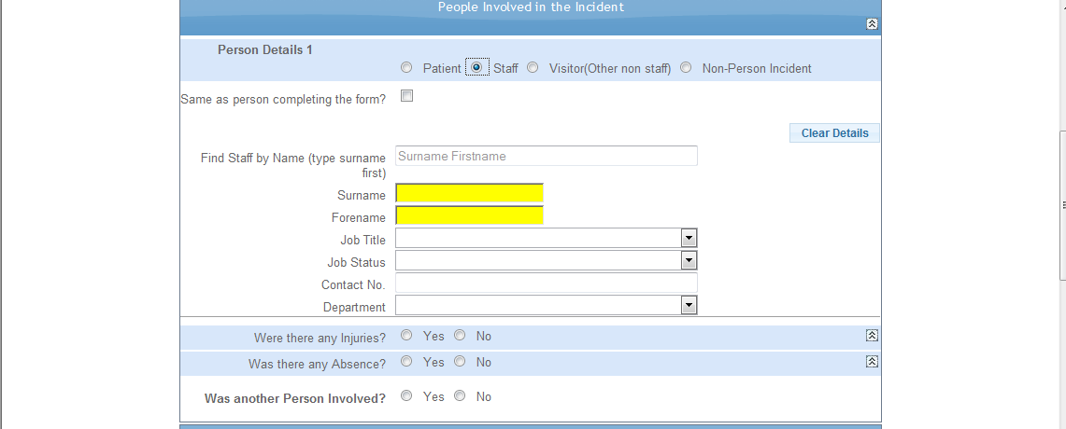

Same as person completing the form | If the details in this section relate to the person completing the form click in the box and your details will be completed automatically
Find staff by name | If you type the last name of the person involved in the incident in this box if they are already on the system you will be able to choose them from the drop down box
Surname & Forename | If neither of the two options above are applicable please enter the person’s surname and forename in the appropriate boxes. – These are mandatory fields
Job title | Please complete if known
Job status | Please complete if known
Contact No | Please complete if known
Department | Please complete if known

Yes/No Boxes

Injuries | If any injuries occurred please click in the Yes box this will open another ‘page’ where you can record details of the injuries.  If there were no injuries please click the No box
Absence | If the injury resulted in time off work, please note the first day of absence here. The return date can be added by the manager when known. This is to help identify RIDDOR incidents (work related incidents which must be reported to the HSE, the most common being lost time of 7 days or more). If there was no absence please click the No box
Was another person involved | Please click either Yes or No

Patient

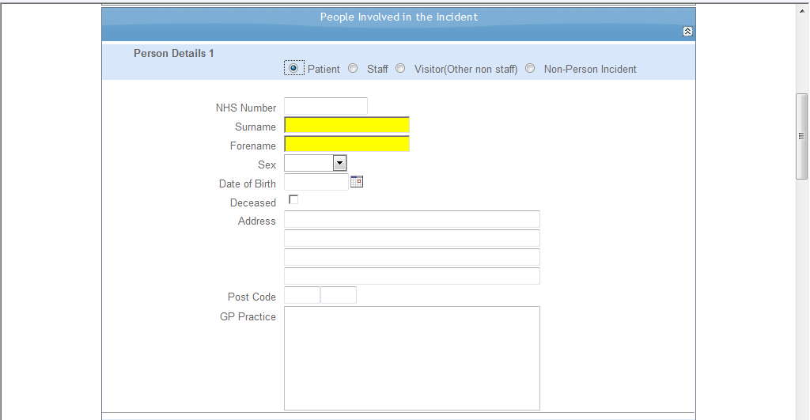

NHS Number | Please enter the NHS number if known
Surname & Forename | Please enter the patient’s surname and forename in the appropriate boxes. – These are mandatory fields
Sex | Please choose from drop down list
Date of Birth | Please complete if known
Deceased | Please tick box if patient is deceased
Address & Post Code | Please complete if known
GP Practice | Please complete if known

Yes/No Boxes

Injuries | If any injuries occurred please click in the Yes box this will open another ‘page’ where you can record details of the injuries. If there were no injuries please click the No box
Patient/Relatives informed | If the patient and/or relatives have been informed please click in the Yes box this will open another ‘page’ where you can record relevant information. If the patient or relatives have not been informed please click in either the No box or N/A whichever is applicable
Restraint (usually applies to Mental Health patients) | If restraint was used please click in the Yes box this will open another ‘page’ where you can record relevant information. If restraint was not use please click in the No box.
Intervention (usually applies to Mental Health patients) | If intervention was used please click in the Yes box this will open another ‘page’ where you can record relevant information. If restraint was not use please click in the No box.
Mental Health details | If there are any mental health details please click in the Yes box this will open another ‘page’ where you can record relevant information. If there are no mental health details please click in the No box.
Was another person involved | Please click either yes or no

Visitor (Other Non Staff) Note details and any injuries

Surname | Please enter visitor’s surname – this is a mandatory field

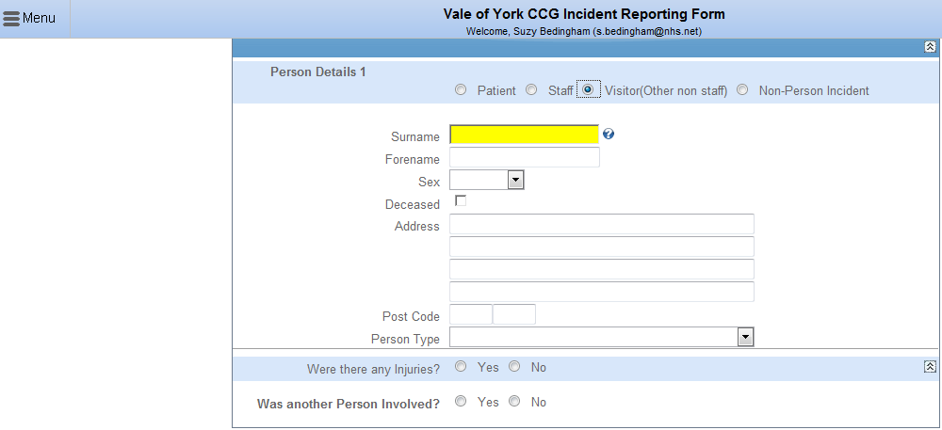

Non Person Incident
Type of property | Choose from drop down list
Description | Free text where you can enter further details. E.g. in the event of a theft you could enter details of what has been stolen

What happened and when

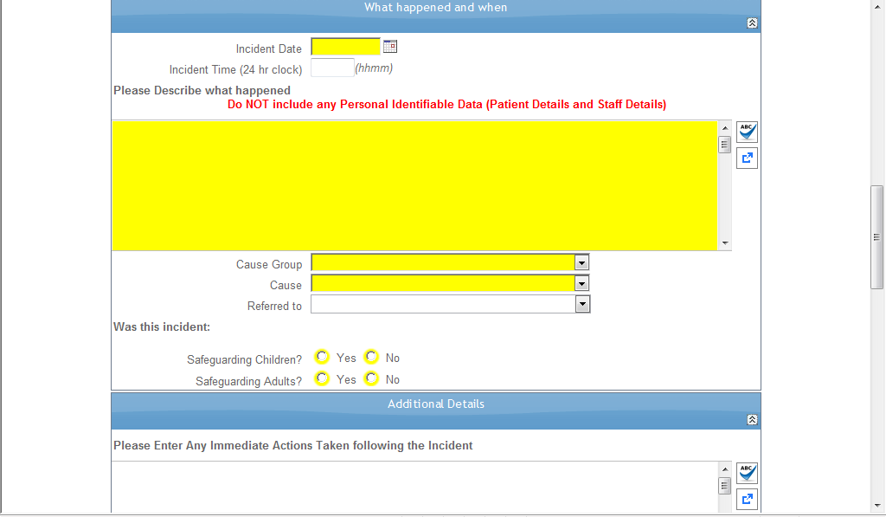

1. Incident date and time | The incident date is a mandatory field. Add the date and time of the incident you are reporting. Use the calendar or the following format ddmmyy.
2.Please describe what happened | This is a mandatory field. Add the details of the  Incident that you are reporting. Record fact not opinion. It is important that no names are included, use job titles or initials, or staff member. Staff details or other involved persons names are noted in the ‘People Involved in the Incident’ section which is the section above this one.  Please complete in sentence case, not CAPITALS.
3.Cause Group | This is a Use the drop down box to select the most appropriate cause group For example it includes information governance, slips trips and falls, and security etc.
4.Cause | This is a mandatory field and is linked to the cause group.
5.Referred to | Who you have referred the incident onto, eg  Manager.
6.Was this incident? | This is a mandatory field you will need to click in both no boxes if it isn’t a safeguarding incident.
7. Please enter any immediate actions taken following the incident | This is an optional free text box for you to enter any immediate action taken.

Details of where the incident happened

Where did the incident take place?
Organisation | There is only one option in this drop down box as this is a mandatory field you need to select it
Site | This is a mandatory field. This is the site where the incident happened e.g. Town Hall, Offsite
Department | This is a mandatory field. The list of departments will relate directly to the site chosen.
Exact Location | This is the exact location of the incident, some examples include kitchen, lift, stairway etc
Location Details | This is a free text field. This allows you to record any specific details about the location e.g whereabouts you were when the incident occurred a particular office etc
Was another department involved | Enables you to record if another dept was involved by clicking in the box.

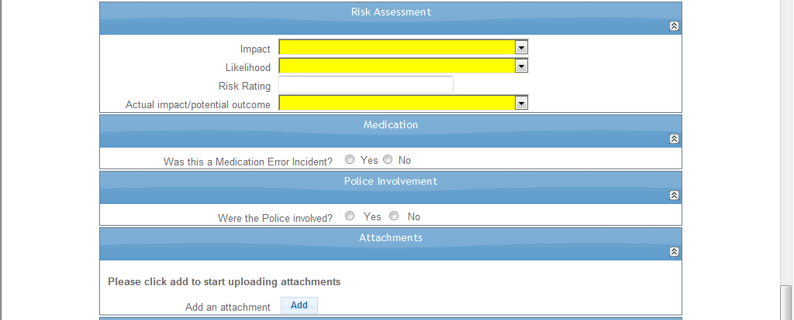

Risk Assessment

These are mandatory, please refer to the Risk Matrix for guidance on Impact and Likelihood when these fields have been selected the risk rating will automatically be calculated.

Actual Impact/Potential Outcome
This is mandatory and is the actual harm (physical and psychological) resulting from this adverse incident on the affected person (patient or staff).

Medication Error Incident
If the section medication error is not applicable there is no need to click ‘no’ if it was a medication error please complete the section with as much information as possible

Police Involvement
If the section police involvement is not applicable, there is no need to click ‘no’ if the police are involved please complete section with as much information as possible.

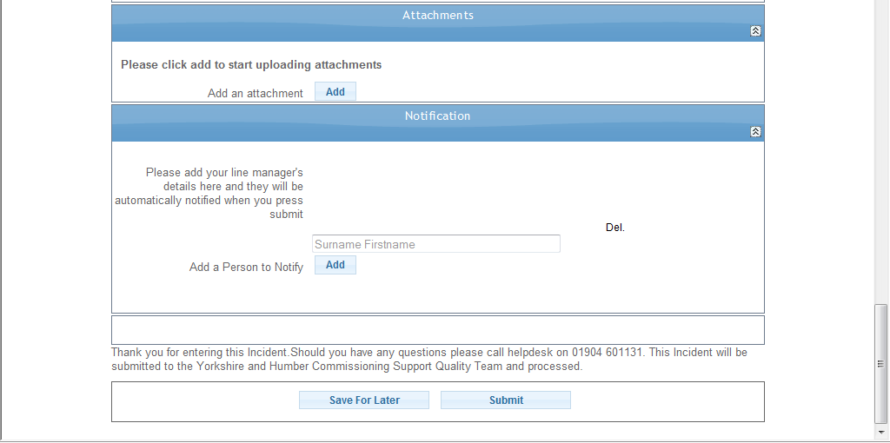

Attachments
If you would like to attach any documents to the form please click on the ‘Add’ button and follow the instructions.

Escalation
Insert your line manager’s email address into the box provided to ensure your line manager gets a copy of the incident form. You can send the form to additional people by clicking on the ‘Add’ button and entering their details.

Save for later
If you don’t have all the information needed to complete the form you can click on the save for later button and finish completing the incident at a later date at this stage the incident is only visible to you. You can retrieve the incident when you log on to Safeguard see image below. To retrieve the incident click on either of the Manage Incident links (see below).

Submit
When you press submit, a link to your incident will be automatically emailed to your manager for review and any appropriate investigation or action.
Depending on the type of incident other staff may also be informed e.g. Information Governance incidents will be emailed to the Yorkshire and Humber Commissioning Support Information Governance team who may contact you for further information.

Sharing learning from any CCG incidents

If there is any learning from an incident which would benefit from wider sharing this will happen either through staff communication or staff briefing.

