Managers Guide to Ulysses Incident Reporting System

Managers Guides to Incidents
You will need to register the first time you use Ulysses. Once the registration process has been completed, you will be able to login using your chosen user ID and password.

If you would like assistance with the registration process or completing the form, please contact Lisa Radoje 07702 975909, lisa.radoje@nhs.net during normal working hours. If you experience any difficulties or error messages, email eryccg.safeguard@nhs.net.

Location of Ulysses: The form is located at - http://srv-uly01/Safeguard/index.aspx?sid=%20

For ease, it is possible to save the Ulysses Safeguard Welcome Page to your desktop or to add it to your favourites.

Sharing Learning from incidents
One of the reasons and values for incident reporting is to try to identify any learning to share which reduces the risk of a repeat occurrence. As the reviewing manager it is your responsibility to consider the incident you have investigated to decide if there is any benefit in onward sharing within the CCG and potentially wider. This approach reflects the national view of the need to share any learning. If you are unsure of whether this applies, or the best way to do this please discuss with the Nursing and Quality team

To manage an incident – log into the incident reporting system, click the Vale of York CCG link to log and manage your incidents (below).

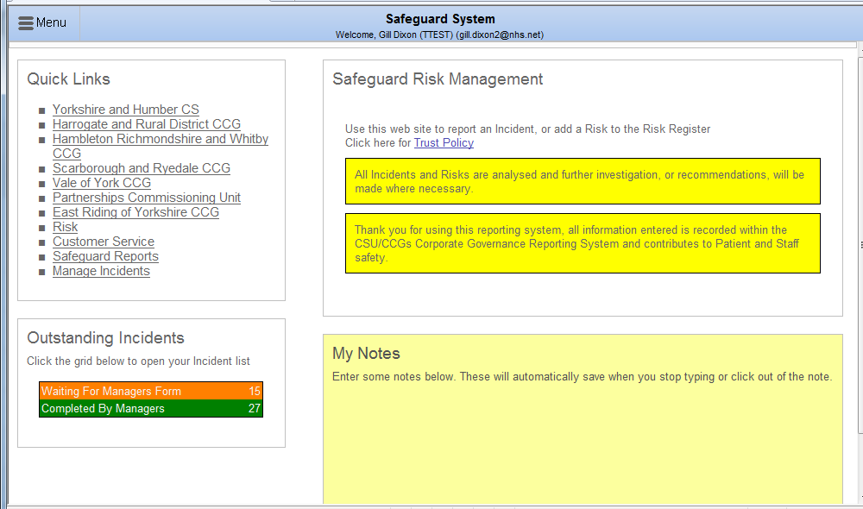
Click here

Managing an Incident
When a member of your team submits an incident report, a link to the incident will automatically be emailed to you as a manager for review and for update to any appropriate action. Depending on the type of incident other staff may also be informed e.g. Information Governance incidents will be emailed to the Embed Information Governance team who may contact you for further information.

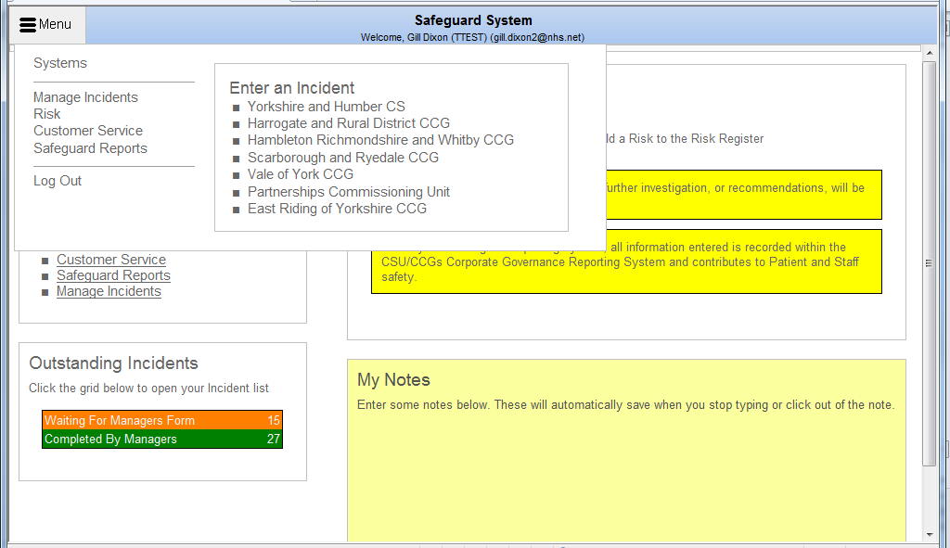
Click here or here
Click here to manage your incident
Once in your incident list, select an incident to manage and click on the right hand side on ‘manager’s form’ to manage that incident.
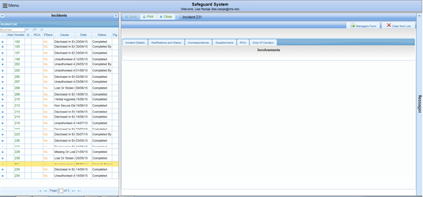
Select incident

The incident will open scroll through incident checking details, the manager’s part of the form is marked in Yellow (below).

In the outcome section the manager will fill in the following areas –
- Actions Taken, and/or Summary of Planned Actions
- Feedback for the reporter
- Recommendations
- Add any attachments such as investigation details or root cause analysis documents
- Either save and close the incident or save it and leave it open for colleagues to review

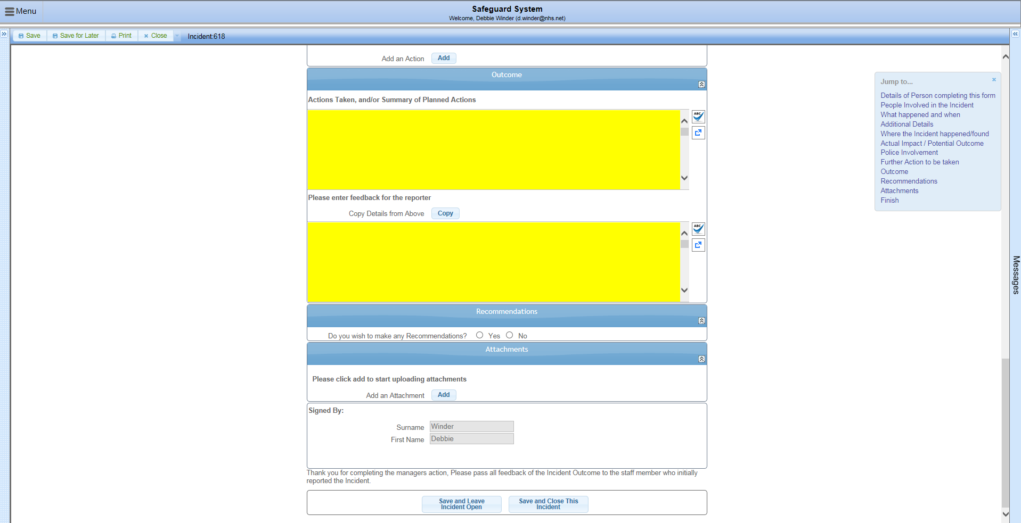
Feedback to reporter
Save & leave open for further review or save and close
Add attachments/
Investigation information
Further recommendations
Actions taken/
Summary

- Section 1 - The manager can add actions, note the actions taken or the actions that are planned to be taken in the first section.
- Section 2 - In the next section the manager can add any feedback to the person who logged the incident
- Tick box – if you tick yes in this section then further free text boxes will open
- Section 3 - If you wish to add any documents such as your investigation templates please click add and upload from your Y drive.
- Save and leave open for further review or save and close incident

